Horizontal Beam engine
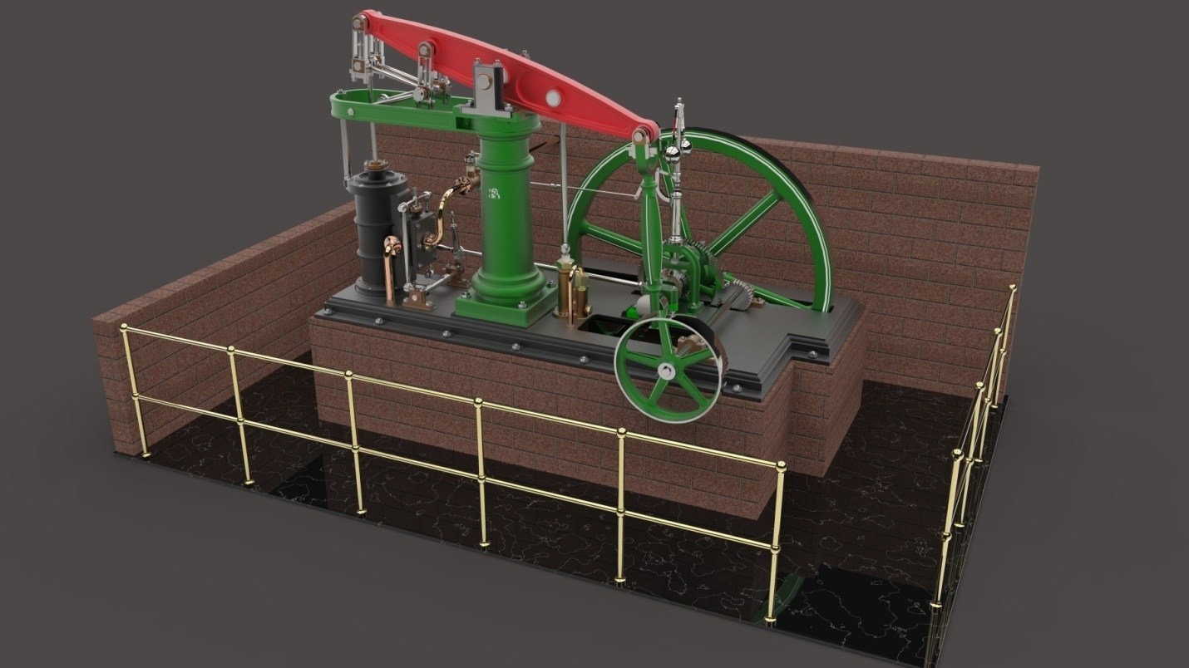
Abstract: A beam engine is a type of steam engine in which beam is pivoted on the top which can apply the force on both the direction. Fly- wheel push down the piston when connecting rod moved forward and the piston rises at back word motion along with pressure and water. Beam engines are extensively used in mines to remove water from ground level. On end is connected to piston and other end is connected to the fly wheel for transmission. This type of engines are mainly used in marine ships, mines, near water cannels etc.
The main objective of this project is to create a model of beam engine in SOLID WORKS 2014.

